Semester two Examination, 2019

Question/Answer booklet

MATHEMATICS SPECIALIST
UNITs 3 & 4

Section One:

Calculator-free

Your Name

Your Teacher’s Name

Time allowed for this section
Reading time before commencing work: five minutes
Working time: fifty minutes

Materials required/recommended for this section
To be provided by the supervisor
This Question/Answer booklet
Formula sheet

To be provided by the candidate
Standard items: pens (blue/black preferred), pencils (including coloured), sharpener, correction fluid/tape, eraser, ruler, highlighters

Special items: nil

Important note to candidates
No other items may be taken into the examination room. It is your responsibility to ensure that you do not have any unauthorised material. If you have any unauthorised material with you, hand it to the supervisor before reading any further.

Question | Mark | Max | Question | Mark | Max
1 |  | 6 | 5 |  | 9
2 |  | 6 | 6 |  | 7
3 |  | 12 | 7 |  | 5
4 |  | 6

Structure of this paper

Section | Number of questions available | Number of questions to be answered | Working time (minutes) | Marks available | Percentage of examination
Section One:  Calculator-free | 7 | 7 | 50 | 51 | 34
Section Two:  Calculator-assumed | 13 | 13 | 100 | 100 | 66
 |  |  |  | Total | 100

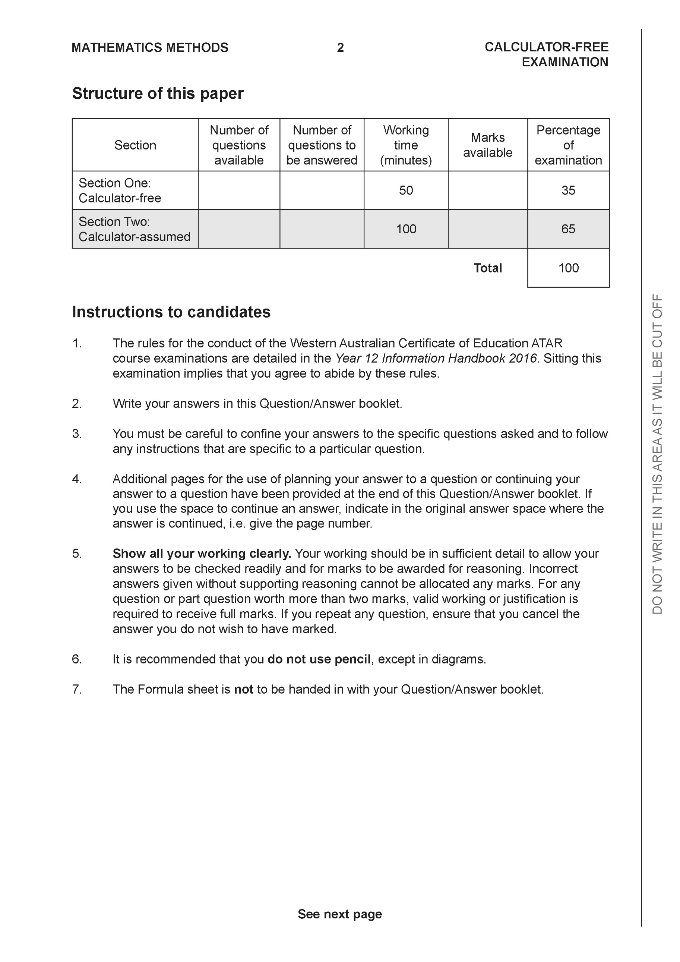

Section One: Calculator-free (51 Marks)

This section has seven (7) questions. Answer all questions. Write your answers in the spaces provided.

Spare pages are included at the end of this booklet. They can be used for planning your responses and/or as additional space if required to continue an answer.
● Planning: If you use the spare pages for planning, indicate this clearly at the top of the page.
● Continuing an answer: If you need to use the space to continue an answer, indicate in the original answer space where the answer is continued, i.e. give the page number. Fill in the number of the question that you are continuing to answer at the top of the page.

Working time: 50 minutes.

Question 1 (6 marks)

Let and .
Determine:
- the natural domain and range of . (2 marks)

- (1 mark)

- the natural domain and range of (3 marks)

Question 2 (6 marks)

Consider the following system of linear equations.

- Solve for . (3marks)

- For the following system where are constants, determine

the possible values of for i) no solutions
ii) infinite solutions. (3 marks)

Question 3 (12 marks)
Determine the following integrals.

- using (3 marks)

- (3 marks)

- (3 marks)

d) (3 marks)

Question 4 (6 marks)

- Express the following expression into partial fractions (3 marks)

- Hence evaluate (Do not simplify) (3 marks)

Question 5 (9 marks)

Consider a plane that contains the following points, .

- Determine a vector equation for all points in the plane above. (3 marks)

- Determine the distance of point from the plane in part a. (3 marks)
(Do not simplify)

- Determine the cosine of the angle that the line makes with the plane in . (3 marks)

Question 6 (7 marks)

Consider the logistical model defined by where are positive constants.
- Determine the value of , ,where . Explain the significance of this value.
(2 marks)

- Derive the logistical formula showing steps in your working. (5 marks)

Question 7 (5 marks)

Evaluate the following integral showing all working. (Simplify)

End of section one

Acknowledgements

